
NHRC-10 Programmer
User Guide
Software Version: | 1.00
User Guide Version: | 2004-03-30

Copyright Notice

Copyright © 2004 by NHRC LLC
This document contains proprietary information that is the confidential property of NHRC LLC.
No part of this document may be used or reproduced, by any means, or for any purpose, without the express written consent of NHRC LLC.
No part of this document should be considered to be specifications for the proper or correct operation of the NHRC-10 Programmer. In no way will NHRC LLC be liable for direct or indirect damages to the controller or attached equipment.

Warranty

This software is supplied at no charge with absolutely no warranty. It may or may not be suitable for the purposes described in this manual. In no case will NHRC LLC be liable for any direct, consequential, or incidental loss or damage resulting from the use or inability to use this software.

Printed in the U.S.A.

Welcome!

Thanks for buying our products.

We have made this programming software available to you free of charge, with no support whatsoever. If you should experience difficulty or discover a problem, we’d love to hear about it, but we are under no commitment to fix the problem for you.

Please review this manual carefully before putting this software into operation.

This software is delivered as-is at no charge. Support for the software is not available. It works on our computers. However, we are interested in your feedback about the software. Email your questions and comments to software-support@nhrc.net. Telephone support requests will be refused.

1. Introduction 7
1.1 Supported Computer Platforms 7
1.2 Controller Interface 7
2. Using the NHRC-10 Programming Software 8
2.1 Installation 8
2.2 Starting the NHRC-10 Programmer 10
2.3 Basic Operation 11
2.3.1 Loading Data 11
2.3.2 Editing Data 13
2.3.3 Saving Data 13
2.4 Uninstalling the NHRC-10 Programming Software 15
3. Editing The NHRC-10 Configuration Data 16
3.1 Edit Autodials 17
3.2 Edit Autopatch Configuration 18
3.3 Edit Control Operator Switches 21
3.4 Edit Courtesy Tones 22
3.5 Edit CW ID 22
3.6 Edit Emergency Autodials 23
3.7 Edit Prefixes 24
3.8 Edit Timers 25

Introduction
The NHRC-10 Programming software allows you to easily manage all the programming data in your NHRC-10 Repeater Controller. It allows you to read all the configuration data from your NHRC-10 repeater controller to your PC, edit the data, save the data to disk, and write the changed data back to your controller. It will support as many different controller configurations as you have disk space for, and you can edit your controller data without the controller connected.
The computer communicates with the controller through a serial interface into the controller’s CI-V port.

Supported Computer Platforms
The NHRC-10 Programming Software is developed to run on Windows 2000 or Windows XP. It may work in prior versions of Windows, but is not supported on any platforms other than Windows 2000 and Windows XP.
The software requires about 150 Kbytes of disk space. Each saved repeater configuration requires 8 Kbytes.
In order to communicate with NHRC-10 controllers, the computer must have a RS-232 port on COM1: available. A CI-V interface is required to connect to the controller.

Supported Repeater Controller Software
The NHRC-10 Programming Software is written to be compatible with NHRC-10 software version 1.20. New features in future NHRC-10 software versions may not be supported by this software.

Controller Interface
The NHRC-10 programming software communicates with the target NHRC-10 controller through the computers serial port into the controllers CI-V port. The RS-232 port on your computer cannot be directly connected to a CI-V device. A CI-V interface box is required.
An Icom CI-V interface can be used, a CI-V interface circuit from the internet, or a Yaesu ADMS cable can be used with an adapter.
You must provide your own CI-V interface.

Using the NHRC-10 Programming Software
This section of the manual describes how to use the NHRC-10 Programming Software.

Installation
The NHRC-10 Programming Software is distributed by electronic download or on 1.44 MB floppy. The installer consists of a Microsoft Setup package called “Setup NHRC-10 Programmer.msi”.
To install the NHRC-10 programming software, locate the msi file with the Windows Explorer program by clicking on “My Computer” and then navigating to the diskette or folder where the “Setup NHRC-10 Programmer.msi” is. Double-click on the “Setup NHRC-10 Programmer.msi” file to start the installation.
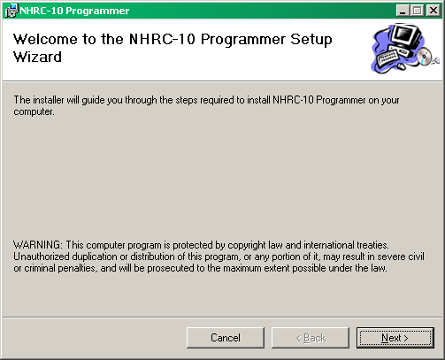
When the installation starts, click the “Next” button to start the installation process. The installer will them prompt you for the location to install the NHRC-10 Programmer and which users should have the NHRC-10 startup icon added to their start menus.
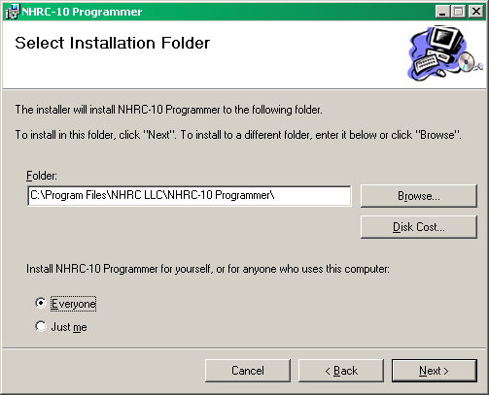
It is quite reasonable to accept the defaults and simply click “Next” on this dialog.
The installer will then install the software. A few more clicks of “Next” and the installation successful message will be shown. Click “Close” to finish the installer.
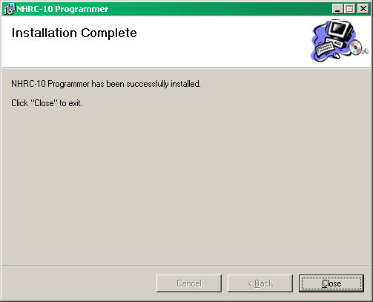

Starting the NHRC-10 Programmer
To start the NHRC-10 Programming Software, press the Windows “Start” button. Select “Programs” and navigate to the menu called “NHRC”, clicking on the “NHRC-10 Programmer” selection. This will start the program. The main window will be displayed
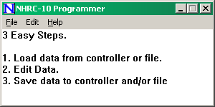
The main window displays a simple guide to using the program. The following sections will describe the three main tasks in using the NHRC-10 Programmer.

Basic Operation
The NHRC-10 Programmer application is used to edit NHRC-10 Repeater Controller configurations. All the configuration data in the controller’s EEPROM can be edited with this program. Audio tracks are not stored in the configuration EEPROM and cannot be edited with this program.
In order to edit the controller data, the program must first load the data from either a controller, or a controller configuration data file stored on the computer.
Once the data is loaded, the program can be used to edit it.
Finally, when the configuration data has been edited, it should be saved to computer disk and/or into a NHRC-10 repeater controller.

Loading Data
Controller data can be loaded from disk files stored on the computer, or loaded from a NHRC-10 repeater controller.

Reading controller configuration files from disk
To read controller data files from disk, use the “File” menu “open” selection. A Windows file dialog box will appear, and you will be able to navigate to and select the controller data file you want to edit.
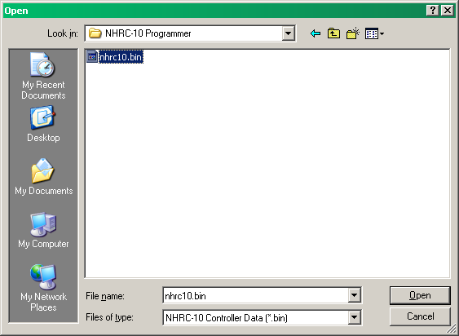
The NHRC-10 Programmer includes a sample data file. This data file is installed to the same location the application files were, normally
C:\Program Files\NHRC\NHRC LLC\NHRC-10 Programmer\nhrc10.bin
This configuration file contains the default (as initialized) data from a NHRC-10 repeater controller, and is the same as starting off by reading a freshly initialized controller.
When a file is selected and successfully read by the NHRC-10 Programmer, the filename will appear in the title bar.
Reading controller configuration data from a controller.
Connect the CI-V interface to your computer’s COM1 serial port and the controller’s CI-V port.
Select the “File” menu “Read From Controller” option.
The controller data will begin to transfer, and the “Transferring Data” message will appear.
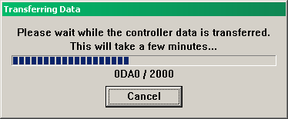
The configuration data takes between two and three minutes to transfer.
If the CI-V interface is not correctly connected, one or more error messages will appear and the data will not be successfully transferred.
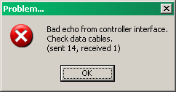
Controller is not powered up.
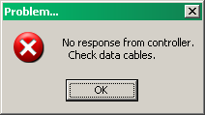
Controller not connected.
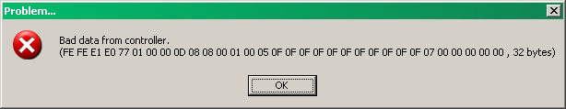
Controller lost power during transfer

Editing Data
Once valid configuration data has been loaded into the NHRC-10 Programming Software, the next step is to edit the data. The “Edit” menu provides access to all the editing functions of the software, including
- Timer Presets
- Command Prefixes
- Autopatch Setup including restrictions
- Autodial Setup
- Emergency Autodial Setup
- Access to all Control Operator settings for all saved states
- Courtesy Tones
- CW ID message
The functions on the Edit menu are described in detail in Section 3 of this manual.

Saving Data
Controller data, once edited, should be saved to a disk file and/or to a NHRC-10 repeater controller.

Saving Configuration Data to Disk
To save controller configuration data to disk, select either the “File” menu “Save” or “Save As…” option. The “Save As” choice will cause the “Save As” dialog box to appear. Choose a directory, specify a file name, and click the “Save” button to save the controller configuration data
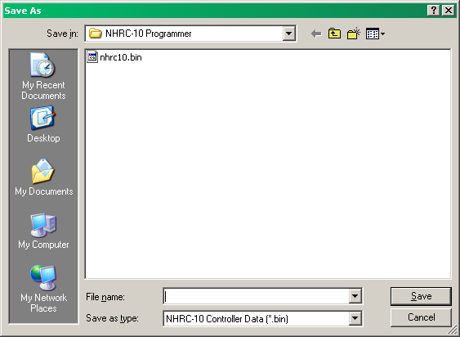
If you select the “Save” option, and you have already specified a file name (either by previously loading a file, or by using the “Save As…” function) the program will quietly save your data to disk.
If “Save” is selected, and a file name has not already been specified the “Save As” dialog will be shown, and you will have to select a location and filename to save the file.

Saving Configuration Data into a Controller
To load the controller with the edited data, use the “File” menu “Write to Controller” option. The “Transferring Data” window will appear, and the data will be transferred to the controller. It takes about 3 minutes to transfer the data to the controller.
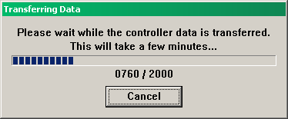
If the configuration data cannot be successfully transferred, one of the three error messages shown in section 2.3.1.1 will be displayed.
Caution: The transfer of data writes the EEPROM as the data is received. If the transfer does not successfully complete, the controller’s configuration data is in an unknown state (at best!), and should be reloaded completely.

Displaying Version Information
The version number and copyright information can be shown by selecting the “Help” menu “About” option.
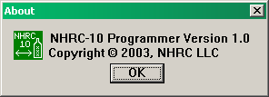

Uninstalling the NHRC-10 Programming Software
The NHRC-10 Programming software can be removed from your computer by using the “Add or Remove Programs” icon in the Windows control panel. Select “NHRC-10 Programmer from the list of programs in the “Add or Remove Programs” window and press the “Remove” button. Press “Yes” to the “Are you sure you want to remove NHRC-10 Programmer from your computer, and the program will be uninstalled.

Editing The NHRC-10 Configuration Data
All the configuration data used by the NHRC-10 that is stored in EEPROM can be edited with the NHRC-10 Programmer. The voice recorder tracks are not stored in the controller’s data EEPROM and cannot be edited by this software.
The configuration data is all edited by selecting functions on the “Edit” menu.
The choices on the “Edit” menu include options for “Autodial”, “Autopatch”, “Control Operator Switches”, “Courtesy Tones”, “CW ID”, “Emergency Autodials”, “Prefixes” and “Timers”.
Each option will be discussed in the following sections of this manual.

Edit Autodials
The NHRC-10 Repeater controllers support an autodial directory of up to 250 phone numbers of 15 digits each. The NHRC-10 Programmer makes editing autodial data a snap! Use the “Edit” menu “Autodials” option to display the “edit Autodials” window
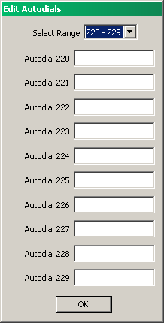
This window allows editing of up to 10 autodial slots at a time. It consists of a “Select Range” dropdown menu and 10 autodial slots. Use the “Select Range” control to choose which 10 are displayed. Edit the telephone numbers and click “OK” to close the window.

Edit Autopatch Configuration
The NHRC-10 repeater controller has a “restricted autopatch” feature. The restricted autopatch feature allows the repeater controller to enforce a set up rules about what telephone numbers can be called.
The restricted autopatch allows up to 16 different area codes to be programmed. Each area code can restrict or require the use of a leading “1” digit, use a dial prefix (for long distance access or a “9” outside line digit for PBX operation). One area code bank (#15) can be specified as the local area code to allow 7- or 8-digit dialing.
In addition to those rules, each of the 800 possible exchanges within an area code can be individually restricted.
Consult the “Program Autopatch Restrictions” of your NHRC-10 Repeater Controller manual for more details on how the autopatch restrictions work.
Use the “Edit” menu “Autopatch” option, and select which of the Area Code configurations you want to edit.
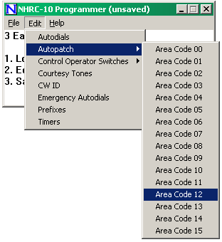
The “Edit Autopatch Configuration” window will be displayed.
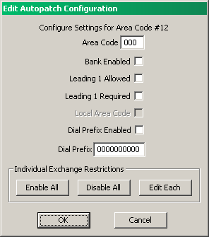
Enter the area code in the area code field.
If this area code bank is to be enabled, check the box.
If a leading “1” digit is allowed when calling this area code, check the “Leading 1 Allowed” box. This will allow 10- and 11- digit dialing, provided the first digit in an 11-digit sequence is a 1.
If a leading “1” is required when calling this area code, check the “Leading 1 Required” box. This will require that the called number is 11 digits long and the first digit is a 1.
IF you are editing the configuration data for area code #15, the “Local Area Code” box will be active. Check this box to allow the settings for area code 15 to be use for all 7 and 8 digit telephone numbers.
To have this area code always dial a certain prefix before dialing, check the “dial prefix enabled” box, and enter the prefix in the “Dial Prefix” field. (example “9” or “10288”.)
The restrictions for the individual exchanges 200 through 999 can be edited using the “Enable All”, “Disable All”, and “Edit Each” buttons. Clicking “Enable All” will set all exchanges (from 200-999) to enabled (dialable). Clicking “Disable All” with set the exchanges disabled (undialable). Clicking the “Edit Each” button will display the “Edit Exchanges” window.
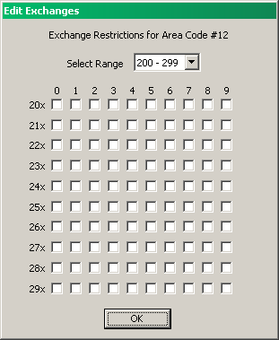
The Edit Exchanges window allows for any exchange from 200 to 999 to be individually edited. 100 exchanges can be seen at once. Use the “Select Range” dropdown menu to select a different range of exchanges to edit. Click the “ok” button when done.

Edit Control Operator Switches
The NHRC-10 has 80 control operator switches that adjust features on the controller. The controller can save the state of all 80 control operator switches. Five saved states are permitted. Saved state number zero (0) is loaded at controller power up.
The NHRC-10 Programmer software will allow you to edit the values saved in each of the saved setups.
Use the “Edit” menu “Control Operator Switches” option, and select which of the saved state configurations you want to edit.
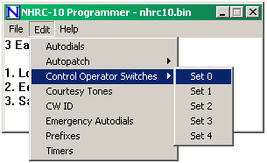
Once you select a set, the Edit Control Operator Settings window will be shown.
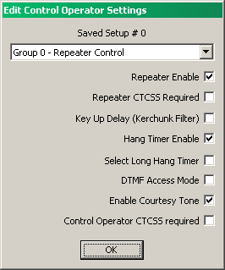
Use the drop down menu to select which Control Operator Group you want to edit. The names to the left of the checkboxes will change as you select different groups. Check the boxes to enable features you want. Consult the NHRC-10 manual for a description of each control operator switch.

Edit Courtesy Tones
All eight courtesy tones can be edited with the NHRC-10 Programmer. Use the “Edit” menu “Courtesy Tones” option to display the “Edit Courtesy Tones” window.
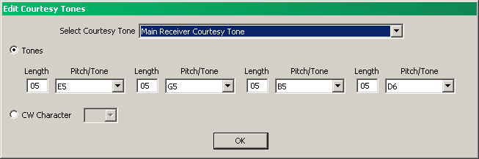
The dropdown menu at the top of the window selects which of the eight courtesy tones is displayed in the window. Each courtesy tone can be programmed as either a sequence of up to 4 audio tones, or as a single CW character.

Edit CW ID
The NHRC-10’s CW ID can be edited with the NHRC-10 Programmer software. Use the “Edit” menu “CW ID” option to display the “Edit CW ID” window.
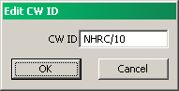
Type the ID message you want to use, then click OK.

Edit Emergency Autodials
The NHRC-10 supports 10 Emergency Autodial slots in addition to the 250 Autodial slots. The phone numbers stored in the 10 Emergency Autodial slots can be edited with the NHRC-10 Programmer. Select the “Edit” menu “Emergency Autodials” option to display the Edit Emergency Autodials window.
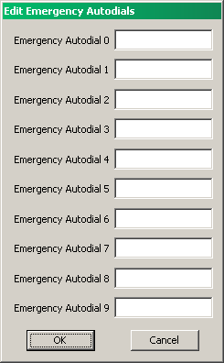
Edit the telephone numbers for each slot, and click OK.

Edit Prefixes
All the user commands for the NHRC-10 require a prefix to secure access. The NHRC-10 Programmer can edit the prefixes. Use the “Edit” menu “Prefixes” option to display the Edit Prefixes window.
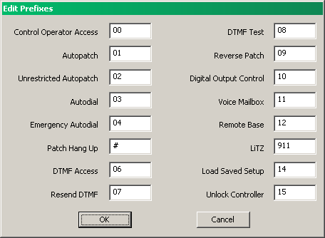
Enter the prefixes and click OK. Consult the NHRC-10 manual for more information on the command prefixes.

Edit Timers
Each of the 14 timers in the NHRC-10 can be programmed with the NHRC-10 Programming software. Use the “Edit” menu “Timers” option to display the “Edit Timers” window.
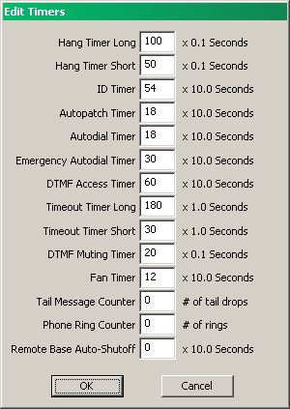
Type your timer values and click OK to accept the changes. Consult the NHRC-10 manual for information on timer uses and default values.

